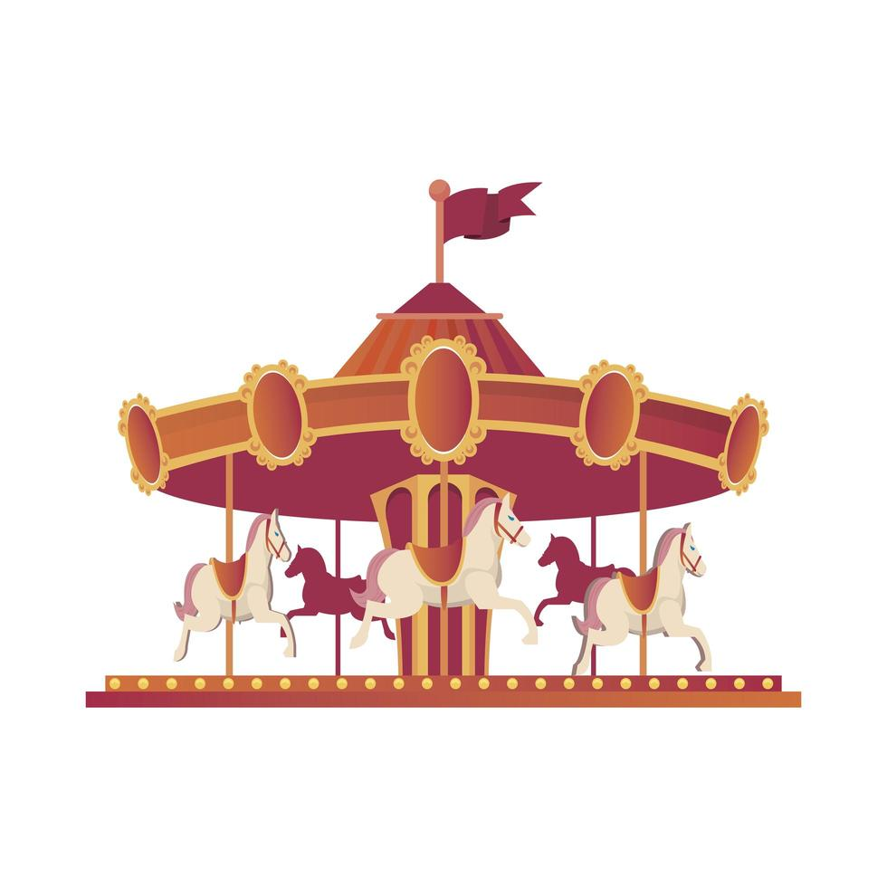

‘My Fantastical Fair ‘
Lesson Plan for Key Stage 1

This session is intended to give pupils an opportunity to share their own experiences of fun fairs both in the UK and in
other countries. Where pupils have little or no experience and have not visited Loughborough fair or market, there
are clips and images to help them visualise it.

The history of Loughborough Fair is outlined in images and clips on an accompanying power point to give the pupils an appreciation of how this important event came to exist and how it has changed over the years.

The introduction should take around 15-20 minutes depending on the age of the pupils.

A walking visit to Loughborough Fair or marketplace would be of benefit to the lesson but is not essential.

Key Stage 1 Curriculum links
- Hi1/1.3 History: Significant historical events, people and places in their own locality.
Learning objectives
- Pupils will learn about the 800 year history of Loughborough fair and market from a range of sources of information – stories, photographs, video clips etc.
- Pupils will contrast how markets and fairs of the past are different from those we have today and how they have changed over time.

Learning Outcomes:
- Pupils will have learnt about the history of Loughborough Fair and Market which celebrates it’s 800 year anniversary this year.
- Pupils will have an appreciation of the significance of the fair and market on the local area and people
- Pupils will have produced a piece of artwork based on, either, a fairground ride they have enjoyed, or an imaginary fairground ride they would love to go on.

INTRODUCTION
To be taught in conjunction with the powerpoint supplied for Key Stage 1.
Slide 1:
- Today we are going to talk about fun fairs and, in particular, one that you might have been to that is 800 years old this year, Loughborough fair! It is held every year in the marketplace and streets of Loughborough in November.
Slides 2-7:
- Who has been to Loughborough fair? Who has been to fair somewhere else – maybe at the seaside or in the country that they come from?
- What rides did you go on? Which was your favourite? What did you see? Which stalls did you visit? Who did you go with? Invite children to share and point out what they can see on the powerpoint photos.
Slide 8:
- Watch excerpts of the clips on the slide. Invite more discussion from the children. What do they think they might be able to smell? If they haven’t visited the fair (or any fair) before, how would they feel walking around?
Slide 9:
History of Loughborough fair:
- 800 years ago: Before 1200 markets used to be held in churchyards, often on special ‘Saints days’ and Sundays. They became a place where people could meet up to sell things they had made or grown themselves. In the 1200’s markets moved into the streets of towns and started to be held on other days of the week. Market squares became important centres to towns for trading things and meeting up. Look at the picture. What are people selling? What are they doing? Can you spot the juggler? How is this different to markets and fairs today?

Slide 10:
- Have you been to the market square in Loughborough? Have you seen the Fearon Fountain in the middle or maybe the sock man? In Medieval times Loughborough market was especially known for selling corn and wool.

Slide 11:
- Markets and fairs needed special royal permission (from the King) to take place. Fairs usually took place every year and lasted for a few days. In medieval times, exotic oils and food, fine furs and clothes from distant lands started to be sold alongside local goods and lots of different entertainments would have taken place such as jesters, musicians, actors putting on plays and dancing bears!
Slide 12:
- In 1221 King Henry III granted permission (a charter) to the Lord of the Manor of Loughborough (Hugh Dispenser) to hold a market every week on a Thursday and a 2 day fair every year in August.
- In 1228 the fair moved to November, which is where it has stayed to this day!
Click on the link to see the Charter being read out.
- There have been times in history when Loughborough fair did not go ahead. Why wasn’t there one in 2020?
- 1609 – 1648. There were many outbreaks of the ‘Black Death’. Loughborough was quarantined, much like last year. People fell sick and could not harvest the crops to sell.
- Also, in this century (1622) there was a great fire in Loughborough which swept through the town. Lots of the buildings were made of wood so it spread quickly.
- On 31st July 1735, ‘The Great Flood’ happened on market day with water ‘as high as a horse’s belly’ in the marketplace.
- Can anyone think of any other reasons why the fair might have been cancelled? – World War 1 – the fair was cancelled from 1915 -1919
- World War 2 – the fair was cancelled from 1939 – 1943. Why do you think this was? (think about blackouts, rationing, safety etc). The market carried on, but food was in short supply because of rationing. When a delivery of biscuits arrived in the market there was nearly a riot! And people queued in a blizzard to buy oranges!

Slide 13 - 16:
- During the 1800, fairground rides started to be mechanised (have motors in them) and started to look more like the fairground rides we have today. There were also lots of different stalls.
- Harry Hall’s boxing booth
- Sedgewick’s lion show – can you imagine having a lion show at a fair!
- Bolesworth and Richard’s cake walk
- Harry Hall’s gallopers

Slide 17:
- The slide shows the marketplace around 1913. How does it look different to today? Where are the roads and cars? What are people wearing?
Slide 18-21:
- Market place and fair circa 1940
- Ghost trains, dodgems and waltzers appeared by the 1940’s

- By 1960 the fair filled the whole of the marketplace. Nowadays, every year approx. 100 show people bring their rides and stalls to Loughborough’s street fair. It’s one of the oldest in Europe!

Activity:
Slide 22:
Charnwood Museum in Loughborough, which you might have visited, is having a big exhibition in the summer to celebrate the fact that Loughborough market and fair is 800 years old. They are asking children from around Loughborough and Charnwood to produce some drawings that are going to be displayed on a big picture window in the museum at the opening of the exhibition.
This is where we need your help.
We would like you to do a colourful drawing or painting of a ‘Fantastical Fairground’ ride that you would love to go on if you could. It might be a roller-coaster, a round-about or a swing. It might have water sprays or lasers and lights. Will it be scary? Will it make you laugh or scream? What sound effects will it have? What will you sit on?
OR you could draw a picture of a fairground ride that you have been on that you loved.
Paper size A4
Materials – pencils crayon, felt tip, paint

Slide 23:
Events that you will be able to go to with your family and friends this year.

