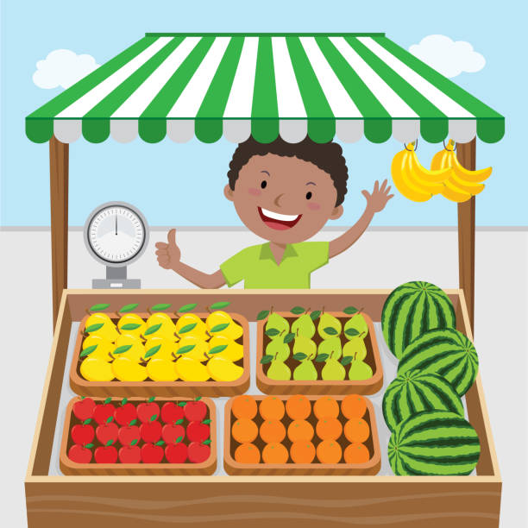
‘My Magical Market ‘
Lesson Plan for Key Stage 2

This session is intended to give pupils an opportunity to share their own experiences of markets both in the UK and in
other countries. Where pupils have little or no experience and have not visited Loughborough market, there
are clips and images to help them visualise it.

The history of Loughborough Market is outlined in images and clips on an accompanying power point to give the pupils an appreciation of how this important event came to exist and how it has changed over the years.

The introduction should take around 20 minutes depending on the age of the pupils.

A walking visit to Loughborough marketplace would be of benefit to the lesson but is not essential.

Key Stage 2 Curriculum links
- Hi2/2.1 History: A local history study. A study over time tracing aspects of national history reflected in the locality. A study of an aspect of history significant in their locality.
Learning objectives
- Pupils will learn about the 800 year history of Loughborough market from a range of sources of information – stories, photographs, video clips etc.
- Pupils will contrast how markets and fairs of the past are different from those we have today and how they have changed over time.

Learning Outcomes:
- Pupils will have learnt about the history of Loughborough Market and Fair which celebrates it’s 800 year anniversary this year.
- Pupils will have an appreciation of the significance of the market on the local area and people.
- Pupils will have produced a piece of artwork based on, either, a market stall they have seen or visited, or an imaginary market stall, filled with things they would love to buy themselves if they could.
INTRODUCTION
To be taught in conjunction with the powerpoint supplied for Key Stage 2.
Slide 1:
- Today we are going to talk about markets and, in particular, one that you might have been to that is 800 years old this year, Loughborough Market! Loughborough market is held every Thursday and Saturday in the Market Place and on Market Street in the town centre. Some of you may have visited.
Slides 2-4:
- Who has been to Loughborough Market? Where is it held? Who did you go with? What did you buy? What sorts of stalls did you see? What did you hear – people shouting to sell their wares? What could you smell – fish? Meat? Cooked food? What was your favourite stall?
Slide 5:
- Who has been to a market somewhere else – maybe in another town or on holiday? Maybe a market in the country that they come from? What could you buy there? How is it different to the markets we have in this country? What could you buy?
Slide 6:
- Useful clips to footage of market and stall holders. Click on the ‘walk around the market’ link. What can you see? What can you hear? What do you think you could smell? How were the stall holders feeling on this blustery day?
- Click on the other links to hear from some of the stall holders on the market. What time do they get out of bed on market day? What time do they set up? Does the market get closed in bad weather? How long have the stall holders been doing their job? Why do they enjoy it? How is it different from working in a shop?
Slide 7:
History of Loughborough fair:
Markets have been known around the world since very early times, allowing people to exchange or buy produce, some of which was entirely local whilst other items were from very far away.
In this country, some markets could be found as early as the prehistoric period, but it was later, in Anglo Saxon times when most of our towns and villages were formed, that many of the country’s markets we know today would have started. As farming improved, surplus food and supplies were traded by farmers and artisans.
Early markets were often held on Sundays after church, selling fresh produce and household necessities in the churchyards. They were also social occasions where local people would get together.
In the 1200s markets moved away from churchyards and into the streets and away from Sundays in preference for weekdays. Market squares were developed, usually with a market cross and became the centre of a town’s business life. We are not exactly sure when the market first moved to Loughborough’s marketplace. Loughborough Market was noted for corn and wool.
- Look at the picture. What are people selling? What are they doing? Can you spot the juggler? How is this different to markets today?
Slide 8:
The Charters
Markets and fairs needed special permission from the King to take place.
In 1216, after the death of King John, the lord protector of nine-year-old Henry III, granted Charters in the King’s name to towns who had a Lord of the Manor. In 1221 Henry III granted a charter to the Lord of the Manor of Loughborough (Hugh Despenser). He was allowed to hold a weekly Thursday market and a two-day annual fair on the eve and feast day of St. Peter ad Vincula (1st August).
Hugh Despenser earnt money from the market tolls, which also went to the King. In 1227, when the king was of age, a second Charter was granted: the weekly Thursday market continued and the fair was extended to three days. In 1228 an additional annual fair was granted to be held in November which is when it is still held today!
Click on the link to see the Charter being read out.

Slide 9:
1300 – 1600 Medieval markets and fairs.
In early years, some traders on Loughborough Market came from the town and surrounding villages. They were farmers selling livestock, grain and fish and merchants trading in wool and other goods.

Many weekly markets started by trading on a Sunday in and around churchyards, as there were always plenty of people there who had come to worship. To trade at the market, stallholders paid a toll or fee to the Lord of the Manor. On each market day, a proclamation was read containing a code of conduct (rules for behaviour) with fines for those who did not stick to the rules. Quarrels and fights were banned as were certain weapons and lawful weights and measures for weighing produce had to be present.

The goods sold in the market, such as fat capons (chickens), eggs, butter and cheese, were mainly local, but merchants came from abroad to trade in jewellery and cloth. Rabbits were a common food and large warrens (The Coneries) were owned by the Manor. Fish were also on sale from nearby brooks and streams dammed to form fish pools. Livestock for sale from outlying farms would be driven to the cattle market through the streets. The market also offered dentistry and the sale of remedies and medicines. Workers who needed a job also went to hiring fairs to seek employment as farm labourers and servants would gather at certain times of year.

Wool and woollen garments were for sale. English wool was thought to be the best in Europe. Thomas Burton and Ralph Lemyngton were among several Merchant Staplers living in Loughborough. Both names are familiar to the people of Loughborough to this day.

Over the centuries there have been times when Loughborough market did not go ahead or had to work in a different way. What happened in 2020 that affected the running of the market each week?
- 1609 – 1648. There were many outbreaks of the ‘Black Death’. Strict measures had to be put in place and Loughborough was quarantined, much like last year. People fell sick and could not harvest the crops to sell.
- Also, in this century (1622) there was a great fire in Loughborough which swept through the town. Lots of the buildings were made of wood so it spread quickly.
- On 31st July 1735, ‘The Great Flood’ happened on market day with water ‘as high as a horse’s belly’ in the marketplace.
- Can anyone think of any other reasons why the market might have been cancelled in the last century? -wars.
Slide 10:
- World War 1 – apart from food shortages world war 1 didn’t have a great deal of effect on the market. The fair, however, was cancelled from 1915 until 1919. This slide shows the 5th Battalion Leicestershire Regiment Loughborough departing from the marketplace 11th August 1914.
Slide 11:
- World War 2 - When war broke out in 1939, the fair was cancelled once again. Why do you think this was? (think about blackouts, rationing, safety etc).
- The Ministry of Food took control all food supplies and live auctions at the cattle market ceased temporarily. Happily, the Christmas poultry sales continued. The population faced ever-dwindling food supplies and rising prices, but the weekly markets continued as before. Rationing was in force and when a delivery of biscuits arrived on the market there was a near riot. People queued in a blizzard to buy oranges.
- In 1945 when the war finally ended on VJ Day, the Town Hall and Market Place were lit by fairy lights. In November the Pleasure Fair returned and attracted large crowds thronging the Market Place.
Can you spot the town hall in the photograph?

Slide 12:

- Through the next 5 centuries, traders and famers continued to sell their goods at the market -sometimes over many generations of the same family.
- Into the 19th Century, Loughborough market continued every Thursday and Saturday in the Market Place. The cattle market occupied the main streets of the town every week. Trade in horses and Welsh mountain ponies took place in Wards End and droves of white geese were driven through the town.
The slide shows cattle market in 1890 and goose sellers (actually in Nottingham market) in 1885

Slide 13:
In the early 1900’s the goods for sale were mostly food, clothing and simple household bits and bobs. However, as transport and roads were improving items could come from further afield including fish and seafood from the sea!
Slide 14:
1920’s looking towards High Street. Notice the large electric lamp in the middle of the marketplace and how smartly dressed everyone is. This was the beginning of the age of the motor car, but you can still see a horse and buggy in the distance. Can you spot the market street post box on the left?
Slide 15:
Mid 1930’s. can you spot the cyclist chatting to the traffic policeman in the middle of the road. He is wearing white arm bands and a peaked cap. Maybe he was lost?!!
Slide 16:
1966. The market is beginning to look a lot more like it does today. The large ornate lamps have sadly gone and 3 new sets of electric lamp posts have been put up. Can you spot the town hall?
Slide 17:
Market around 1998. The arrival of the ‘sock man’ sculpture, a symbol of Loughborough’s hosiery industry.
Today, although there is no longer a cattle market (now the Granby Street Car Park), the market is still held in the Market Place and on Market Street – a thriving modern market where many traders have been stallholders for generations.

Activity:
Slide 18:
Charnwood Museum in Loughborough, which you might have visited, is having a big exhibition in the summer to celebrate the fact that Loughborough market and fair is 800 years old. They are asking children from around Loughborough and Charnwood to produce some drawings that are going to be displayed on a big picture window in the museum at the opening of the exhibition.
This is where we need your help.
We would like you to do a colourful drawing or painting of a ‘Magical Market’ stall that you would love to visit and buy things from if you could. What would it sell? You could just draw something you would like to buy.

OR you could draw a picture of a Market Stall on that you have visited in the past and you particularly like. It could be on Loughborough Market or somewhere else you have visited in this country or abroad.
Paper size A4
Materials – pencils crayon, felt tip, paint

Slide 19:
Events that you will be able to go to with your family and friends this year.

