Syston Library: Children’s Art Project

Brief for Artist

Organisation: Leicestershire County Council
Team: Audience Development Team/Libraries/Communities and Wellbeing
Project Background:
Leicestershire Libraries is excited to be seeking an artist to create an artwork for the children’s area in Syston Library.

In September 2021, we will be working with both local primary schools starting with class visits to the library. We are looking for a freelancer to inspire creativity in the children and support them to develop an artwork which they will be proud of for years to come.

The image below is the space currently. The ‘Great Children’s Books’ purple banner will be replaced with the artwork developed by this project.

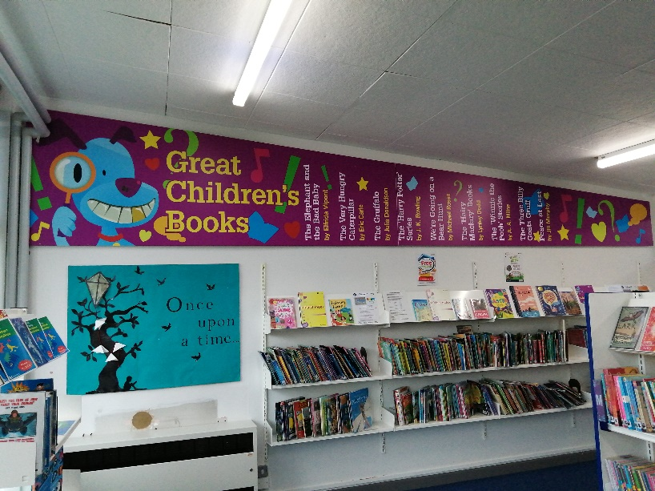

Initial vision
- The space is approximately 19ft long by 3ft wide
- Our initial idea for the theme of the artwork is children’s book characters and we are keen on the focus being their favourite one. However, we are open to exploring other options.
- We would like involvement from each child in the form of drawing/designing/making (whichever is relevant to selected artist)
- There will be 160 children spanning 4 classes from Years 2 and 4. All drawings/artworks must be incorporated into the collaborative piece.
- The artist is expected to add their own ‘style’ of work to bring the piece to life.
- We are very open to proposals from artists using all mediums. We envisage that the final artwork will take the form of a printed board but are open to alternative proposals.

Artist engagement expectations
- Visit both primary schools to lead a one-off workshop with each of the four classes (over two days in September, tbc)
- The children should design their artwork during the workshop, which will then be used in a collaborative final piece, finalised by the artist
- A printed artwork will require the selected artist to have access to their own software for production of a professional quality print file in the agreed format, unless an alternative proposal/method is agreed.

The finished artwork should:
- Be original, vibrant, eye-catching and clearly decipherable
- Be engaging, fresh, colourful and creative in approach
- Appeal to both children and adults alike (including all abilities)
- Be sustainable and have longevity as it will be a permanent feature of the children’s library
- Work as a standalone piece but also compliment the rest of the children’s library décor
- Include both school names and year groups within the artwork, plus additional wording as selected by library staff

Audience considerations
- Children and their families who do or could use Syston library
- The artwork will be viewed by library users from a wide range of ethnicities, cultures, faiths, abilities and ages, so this must be taken into consideration

Project aims
- Empower local families to feel a sense of ownership of the library
- Raise awareness in the local community of the presence of the library
- Increase appeal and profile of the library
- Contribute to increased library usage through ongoing self-led class visits from both primary schools and increased usage by local families after project end
- The collaborative artwork will be relevant, vibrant and robust and have sustainability for the future

Digital file format of finished piece:
We are very open to proposals from artists using all mediums. We envisage that the final artwork will take the form of a printed board but are open to alternative proposals. A printed artwork will require artists to have access to their own software for production of a professional quality print file in the agreed format unless an alternative proposal is agreed. Any printing will be sourced and paid for separately.

Timescales:
- Workshops with the four classes (2 x Year 2, 2 x Year 4) anticipated to take place within last two weeks of September (tbc)
- Final piece (on digital file or physical, dependent on artist proposal) ready to hand over to the Participation Team by Monday 25th October 2021.

You will need to liaise with the team on initial proposal ideas and be flexible in delivery.

Budget:
£1250 inclusive of:
- All travel (to and from the two schools and Syston Library as necessary)
- Four school workshops, including materials
- Design and production of the final artwork (unless on digital file)

Terms and conditions
- To abide by Leicestershire County Council’s data protection and GDPR rules which will be shared with the successful artist
- As a consultant you agree to grant full copyright license to Leicestershire County Council to use any final artwork in any manner it deems appropriate
- All final decisions and approvals will be from LCC

Contact
Please send your initial written proposal (up to one page of A4) and examples of previous similar work to: catherine.overton@leics.gov.uk by Sunday 8th of August 2021. Please include the form your final artwork would take in your proposal, e.g. a digital file to be printed or a physical medium.

We are very excited to see what you can bring to this project and what your take on it would be, therefore all styles will be considered, so long as it fits the brief!

www.cultureleicestershire.co.uk

