

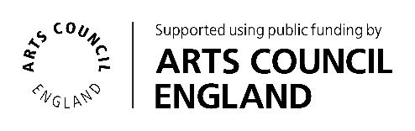

Creative Expressions in Libraries at Broughton Astley Library
Exhibition ‘Tree’ Project

Brief for Creative Practitioner

Commissioning organisation: Culture Leicestershire, Cultural Participation Team
Location: Broughton Astley Library, LE9 6RD
Submission deadline:
We are looking for a Creative Practitioner to create a tree-like structure within the library that will used to showcase future artwork. The structure should therefore incorporate a method of displaying collections of multiple pieces of artwork (individual pieces will have a maximum dimension of 150x200mm). Our aim is to create a permanent exhibition/display structure that provides the community with the opportunity to create new collections and update the display regularly.
Commissioning Organisation
Culture Leicestershire is Leicestershire County Council’s Libraries, Museums, Heritage, Collections, Learning and Participation Services. We have been awarded National Portfolio Organisation (NPO) status and funding from Arts Council England to support them to deliver the ‘Let’s Create’ strategy. For more information please visit:
Arts Council National Portfolio Organisation Investment programme
Culture Leicestershire
Leicestershire Libraries
Our Libraries NPO strand is called ‘Creative Expression in Libraries’. Our aim is to commission specific creative activities to develop new library audiences and make libraries vibrant cultural hubs in our communities. Loughborough Library, alongside three other Leicestershire Library sites, has been identified for the third year of the NPO programme. These libraries will appoint a Creative Practitioner to create new activities for communities, with a focus on Children and Families as a target audience.
Project Activity / Role of Creative Practitioner

We are excited to be seeking a Creative Practitioner to work at Broughton Astley Library to design, build and install a tree-like structure within the library. Photographs of the planned area can be found at the end of this document.
We intend for the structure to be used as a permanent exhibition stand that will display collections of artwork or ‘leaves’ created by the local community on an ongoing basis. We would like the structure to be substantial in size to ensure that multiple pieces of art (a minimum of 12) can be displayed at one time, whilst managing the practical and health and safety considerations that need to be taken into account. The collections of artwork will be changed by library staff therefore consideration is required to ensure that the updates can be made in a safe and accessible manner.
We are open to different designs (2D or 3D) and materials, provided that the structure is robust enough to have longevity and display the intended artwork. The type of structure will directly influence the collections of ‘leaves’ that will be developed with communities at a later stage. For this reason, it will be necessary to work closely with the commissioning Community Participation Worker to ensure that the planned installation is both fit for our purpose and meets health and safety requirements.
Project Vision and Aims
The creation of the tree structure will provide the foundation for a wider project to offer exciting cultural engagement opportunities for the people of Broughton Astley. This wider project will :
- Embed cultural activity into the library during the course of the project
- Provide the basis for future additional groups to use the tree to display the outcomes of community projects
- Connect the library both with its current users and with non-users, promoting community cohesion and the library as a welcoming public space for all
- Promote the library as an accessible and culturally vibrant space
- Meet Arts Council England’s 'Let's Create' aims and ambitions
Creative Practitioner requirements
- To design, build and install a tree-like structure/display within the library that meets the requirements above.
- Meet the necessary health and safety requirements of the site. As the library is accessible to members of the public during unstaffed hours (referred to as Smart mode) considerations include: ensuring the structure/display is not climbable, that the method of displaying the artwork or ’leaves’ is safe (e.g. no ‘open’ hooks or long wires) and that it is securely attached to the wall
- Devise and share risk assessments
- Produce a safe working method statement for the installation of the structure
- To provide content for advertising and recruitment purposes such as images for social media posts
- Provide photographic documentation of the progress of the work, using organisational consent forms where required
- Collaborate regularly with Culture Leicestershire staff, including library staff and local partners if required
- Manage the budget and provide a comprehensive audit trail (please note all materials for the project need be included as part of the Creative Practitioner quote/fee). Any ‘making good’ estimates/allowances should be included, as far as practicable, withing the initial quote
- Whilst we are looking for a permanent/semi-permanent structure and display, there does need to be consideration to its ease of removal with negligible damage to walls as we require flexibility to periodically reconfigure the library space.
Skills and Experience
- Designing, creating and installing permanent or semi-permanent structures within public spaces
- Full understanding and compliance with associated health and safety requirements
- Co-designing installations with partners, tailored to individual need
- Flexibility, including the willingness and ability to adapt designs as needed until final sign off
- Ability to offer innovative ideas that combine something new, inspirational and dynamic with the need for longevity and addressing health and safety considerations
- Good communication skills across a wide range of partners/stakeholders
- DBS clearance or intention to obtain this
Submission Information
The artist should enter a submission using the application form linked below, including the following information:
- Any skills or experience (see above requirements) that demonstrates suitability for this project, including photographs or links to any relevant previous work
- It is essential that evidence of previous work is included in the application
- Details of how the proposed structure will be installed in the library, keeping health and safety as the main priority
- An outline of envisaged timescales for all stages of the project i.e. initial meetings with CPW, design, build and install
- A breakdown of how you would use the budget (please see the application form for more details)
- Details of insurance and liability to deliver the proposed project, or intention to obtain this

Support

Community Participation Workers within the Culture Leicestershire team manage the work of Creative Practitioners commissioned by Culture Leicestershire, providing support, direction and advice. They will be your main contact point. They support liaison with relevant people and groups inside and outside of Leicestershire County Council as well as contract manage the overall project from beginning to end. They will also provide support with payment, evaluation, promotion, partnership work and other aspects of the project.
Process

The Creative Expressions in Libraries, Broughton Astley Library working group will review all submissions. The working group is made up of a Community Participation Worker, Library Supervisors, Library Services Assistants, a Librarian and other relevant partners including those from the target audience.
Submissions should be made by submitting the Creative Practitioner application form, found here on the Culture Leicestershire website. Due to limits on file sizes please include any images, video, or large files as links, or email separately where this is not possible.

Applicants that have been short listed will be invited to have an informal discussion.
Unsuccessful applicants will receive feedback and details will be kept on file (with permission) for future projects.

Timescales

Deadline for expression of interest: Monday 28th July at 10am.
Planning stage to start August 2025
Design finalised by September 2025
Installation to take place October-November 2025.

Budget
The fee available is up to £4,000. This should cover all of your time and materials including
- Initial planning meetings and site visits
- Design, including seeking feedback and revisions from the CPW
- All build costs including your time and the purchase of all materials required
- Installation costs
- Additional costs including admin and transport
You do not need to use the whole budget if it is not required, a strong expression of interest will show a breakdown of costs and clearly demonstrate how the budget will be spent.
Terms and conditions
• To abide by Leicestershire County Council’s data protection and GDPR.
• Leicestershire County Council is committed to ensuring that its services, policies and practices are free from discrimination and prejudice and that they meet the needs of all sections of the community. All provision is expected to be in accordance with this principle.
• As a consultant you agree to grant full copyright license and ownership to Leicestershire County Council to use any final artwork, resource or creative output resulting from the project, in any manner they deem appropriate.
- For all or any aspects of the project to be filmed for the purpose of promotion or training
For informal enquiries, please contact:
Steph Strange, Community Participation Worker
Stephanie.strange@leics.gov.uk
0116 305 8760

Photos of Broughton Astley Library Space

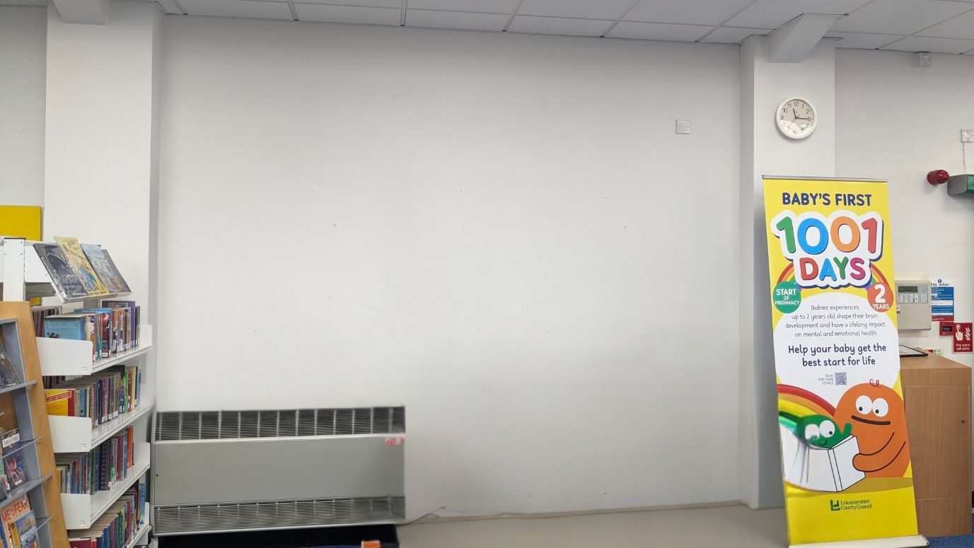

The total width of the space is
The width of the radiator is
The maximum height that artwork can be placed is 2m to ensue that library staff can change artwork safely.

