Loughborough Library NPO Project: Eye Spy Wall Art
Loughborough Schools Workshop Results
Co-creation method
1,020 primary aged children across 4 primary school within Loughborough were consulted. The majority of the consultation took place within class workshops, with the addition of one whole school assembly. Workshops were between 40-60 minutes in length and used different methods to engage the children, including pair work, group discussions, sticker voting, worksheets and drawing. Children also used ‘eye-spy’ books such as Where’s Wally? to think about what eye-spy art means. The children offered their suggestions on:
- Their likes
- Their dislikes
- Potential themes for the artwork
- Elements that the artist could hide
- What objects from Charnwood Museum could be incorporated
- How the artist can hide elements within the art
Finally, the children created their own piece of eye-spy art. Some pieces will be used to create an exhibition to celebrate the launch of the completed artwork.
Results: Likes and dislikes
The results were very clear: the final art piece should not be too easy as it needs to be challenging however it should also not be too hard as if it takes too long they felt everyone would give up. This led to the suggestion from many children that the artwork should have different levels of difficulty within it, some aimed at younger children and some aimed at older. The next most common suggestion was that the artwork should be very bright and colourful. Many children also suggested that the artist should add in puzzle elements, as well as the eye-spy.
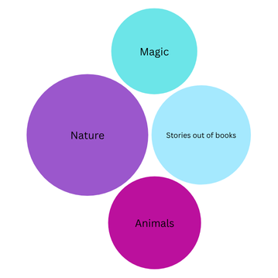
Results: Theme
44 themes in total were identified by the children. The top four suggestions, in order of number of times proposed, were:
- Nature
- Stories coming out of books
- Animals
- Magic

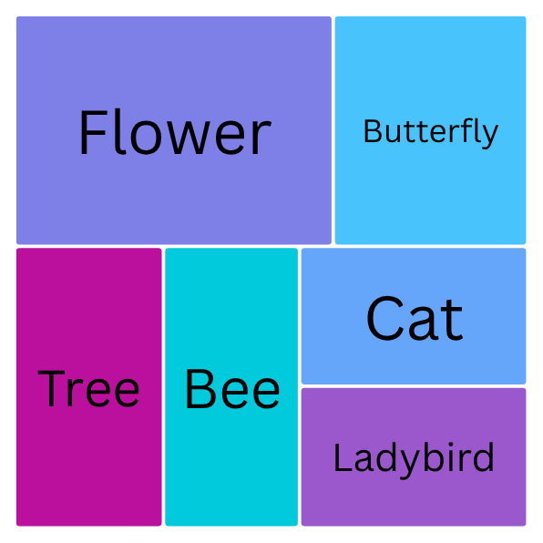
Results: Eye-spy elements
59 suggestions were made, with additional elements found within the later drawings. The elements that were suggested were within the same subjects as the themes that were most put forward: Nature and Animals. Bar one, all suggestions are feasible.

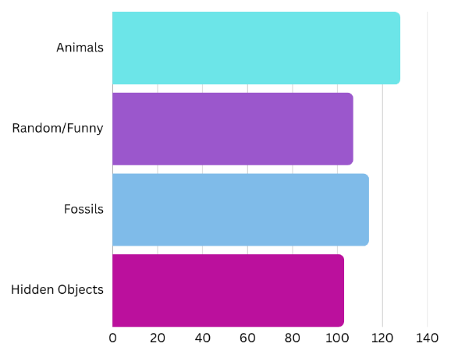
Results: Museum Artefacts
Children voted on which museum artefacts they felt should be included in the artwork. The vote was very close, however animals followed by fossils had the most votes. These objects again tie in well with the chosen theme.

Results: Hiding elements
The final aspect the children were consulted on was how the artist should hide the suggested elements within the art. There were many ideas generated by the groups, with the most common being:
- Hiding things behind other stuff
- Making the picture crowded
- Hiding things with stuff similar to each other
- Having tiny things
- Having lots of detail in the background
- Blending elements with a similar colour background
- Layering elements

