

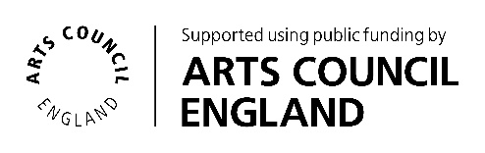

‘Creative Expressions in Libraries’
Ashby De La Zouch Library:
Children’s library artwork

Creative Practitioner’s Brief: We are seeking a Creative Practitioner to create artwork for a large wall space within the children’s area of Ashby Library.
Our aim is twofold - to allow the families co-creating the artwork to feel a sense of ownership of the library, and to also make the children’s area more identifiable for first time users of the library.
*Please read the detailed information below if you wish to apply. There is a separate summary page to give you an overview of the project and to aid your submission.*

Commissioning organisation: Culture Leicestershire, Cultural Participation Team
Location: Ashby De La Zouch Library, North Street, Ashby, Leicestershire LE65 1HU
Submission deadline: Monday 24th November 2025, 9am.
Managed by: Catherine Overton, Community Participation Worker (CPW)
Recruitment by: A panel of staff from the library service, led by the CPW

Commissioning Organisation
Culture Leicestershire is Leicestershire County Council’s Libraries, Museums, Heritage, Collections, Learning and Participation Services. We have been awarded National Portfolio Organisation (NPO) status and funding from Arts Council England to support them to deliver the ‘Let’s Create’ strategy. For more information please visit:
Arts Council National Portfolio Organisation Investment programme
Culture Leicestershire
Leicestershire Libraries
Our Libraries NPO strand is called ‘Creative Expression in Libraries’. Our aim is to commission specific creative activities to develop new library audiences and make libraries vibrant cultural hubs in our communities. Ashby Library, alongside three other Leicestershire Library sites, has been identified for the third year of the NPO programme. These libraries will appoint a Creative Practitioner (hereafter referred to as the CP) to create new activities for communities, with a focus on Children and Families as a target audience.
Project Activity / Role of Creative Practitioner

We are excited to be seeking a CP to work at Ashby Library to create a large piece of art to fit on one side of the wall in the children’s library. The CP will be working with groups of children / families in co-creating the artwork during five workshops. Focus should be on providing a fun activity embedded within the library and in providing a welcoming experience to the children’s library. It should enhance participants’ sense of the value of libraries and cultural activity.

The artwork should be influenced by the theme of the National Forest, to align with the furniture already in situ in the children’s library (see Photo 1 & 2 below).
Consultation has taken place with a small number of local families and further ideas collated by the CPW regarding sub-themes which may also feature in the artwork. These ideas are not prescriptive, and we are very open to your own suggestions, or you may choose to run with one or more of them.
The sub-themes are:
- Stories / Storytelling
- Celebrating Libraries
- Ashby Local History (e.g. the library building having been a school previously)
- Ashby Local Literature link (i.e. Adrian Mole, Ivanhoe, Paddington)
The designated wall space for this artwork is approximately 2.6m X 1.3m. (Please see Photo 3 below for the proposed area). The artwork will need to be a substantial and eye-catching design to grab the attention of library users, whilst also considering time and budget. The artwork is to contain imagery only (no wording) and will help make the children’s area identifiable – especially for first time users of the library.
Five workshops will be delivered by the CP with different groups within the local community, to give opportunity for a range of participants to help shape the work. In terms of the medium(s) used, we are open to all suggestions.
We envisage the following workshops:
- Two afternoons in February (dates tbc), to allow families to come after school
- Two mornings in February (dates tbc), working with pupils from a local primary school
- One Saturday in February (date tbc), to allow families an opportunity to take part who are unable to attend in the week
Once co-designed with our participants, the intention is for the artwork to be created on an appropriate material that is lightweight enough to be hung in place, be colourfast and long lasting. The wall is exposed brick, so this needs to be taken into consideration when planning the correct fixtures to use, as holes will need to be drilled to create a sturdy fixture. (NB - Installation arrangements will be discussed at interview and budget provision for this element will be negotiated on appointment).
The CP will also be responsible for planning and delivering a celebration event once the artwork is in situ (date tbc). Project participants will be invited to this, with an associated activity for them to take part in and to enjoy the unveiling of the finished piece.

Project Vision and Aims
- To offer people in Ashby an exciting, meaningful cultural engagement opportunity in their library
- To give a more obvious identity to the children’s area of the library
- To allow the families taking part in the project to feel a sense of ownership of the library
- To embed cultural activity into the library during the course of the project
- To connect the library both with its current users and with non-users, promoting community cohesion and the library as a welcoming public space for all
- To promote the library as an accessible and culturally vibrant space
- To meet Arts Council England’s 'Let's Create' aims and ambitions

Creative Practitioner requirements
- To develop a piece of art in collaboration with the CPW and project participants to ensure incorporation of the elements as described above
- To plan, manage, deliver and facilitate five workshops to engage participants in co-creating the artwork
- To plan, manage, deliver and facilitate a final celebration event for all participants
- To provide content for advertising and recruitment purposes such as images for social media posts
- Provide photographic documentation of the progress of the work, using organisational consent forms where required
- Devise and share risk assessments for both the workshops and celebration event
- Devise a jointly negotiated risk assessment and method statement required for the installation of the artwork. (NB: The CP is required to be at installation regardless of whether they are responsible for the installation itself)
- Support the collection of evaluation as required by Culture Leicestershire
- Collaborate regularly with Culture Leicestershire staff, including local library staff and local
partners
- Manage the budget and provide a comprehensive audit trail

Skills and Experience
- Creating and co-creating art within the cultural or education sector
- Project Management skills including full understanding and compliance with associated health and safety requirements
- Communicating and working with children and young people
- Connecting with communities using art as a catalyst
- Working within the Cultural and Heritage sectors
- Planning, delivering and co-creating participatory artwork
- Working with community groups and partners including children and families, and bringing people together through culture
- Offering innovative ideas that provide something new, inspirational, and dynamic with a lasting legacy
- Good communication skills across a wide range of partners/stakeholders
- DBS clearance or intention to obtain this

Submission Information
The artist should enter a submission using the application form linked below, or provide a video up to three minutes in length, which includes the following information:
- Any skills or experience (see above requirements) that demonstrates suitability for this project, including photographs or links to any relevant previous work
- It is essential that evidence of previous work is included in the application
- Details of how the proposed work can take place within the library space, bringing people together through cultural activity
- An outline of envisaged timescales for all stages of the project i.e. initial meetings with CPW, planning, delivery, evaluation and length of time needed to create the final artwork
- A rough idea of session plans for the workshops
- A breakdown of how you would use the budget (please see the application form for more details)
- Details of insurance and liability to deliver the proposed project, or intention to obtain this
- Availability to deliver the project on the days in February as listed above.

Support

Community Participation Workers within the Culture Leicestershire team manage the work of Creative Practitioners commissioned by Culture Leicestershire, providing support, direction and advice. They will be your main contact point. They support liaison with relevant people and groups inside and outside of Leicestershire County Council as well as contract managing the overall project from beginning to end. They will also provide support with payment, evaluation, promotion, partnership work and other aspects of the project.

Process

The Creative Expressions in Libraries, Ashby Library working group will review all submissions. The working group is made up of a Community Participation Worker, Principal Manager, Library Supervisor, Library Services Assistants and a Librarian. It may in future also invite other relevant partners including those from the target audience.
Submissions should be made by submitting the Creative Practitioner application form, found here on the Culture Leicestershire website. Please give the file your name and ‘Ashby25’. Due to limits on file sizes please include any images, video, or large files as links, or email separately where this is not possible. Please also rename these with your name and ‘Ashby25’.

Alternatively, please send a recording of up to three minutes in length which covers all the key points to catherine.overton@leics.gov.uk

Applicants who have been selected will be invited to have an informal discussion. Please indicate if you will be unavailable for the proposed interview dates (see below).
Unsuccessful applicants will receive feedback, and details will be kept on file (with permission) for future projects.

Timescales

Deadline for expression of interest: Mon 24th November 2025, 9am.
Proposed date for informal discussion: Mon 8th/ Tues 9th December 2025.
Planning stage to start: December 2025 with activity running for five sessions in February 2026
Art installation date: Approximately eight weeks after activity ends. To be discussed further during informal discussion.
Celebration event date: to be discussed during informal discussion.

Budget

The total sum available is £4,000. This should cover everything listed below. A strong expression of interest will show a breakdown of costs and clearly demonstrate how the budget will be spent. For example:
- Time - this could be a price per participatory session including preparation time, delivery of the session and travel.
- Materials - this should be broken down into costs for participation materials and outcome processes.
- Additional costs - these may include your transportation, administration, and technical services.
- Final creative output costs.
- Cost of a celebration event. Please identify how you would spend this.

Terms and conditions
• To abide by Leicestershire County Council’s data protection and GDPR.
• Leicestershire County Council is committed to ensuring that its services, policies and practices are free from discrimination and prejudice and that they meet the needs of all sections of the community. All provision is expected to be in accordance with this principle.
• As a consultant you agree to grant full copyright license and ownership to Leicestershire County Council to use any final artwork, resource or creative output resulting from the project, in any manner they deem appropriate.
- For all or any aspects of the project to be filmed for the purpose of promotion or training.
For informal enquiries, please contact:
Catherine Overton, Community Participation Worker
catherine.overton@leics.gov.uk
0116 305 2507

Supporting photographs (please scroll down to see all three):

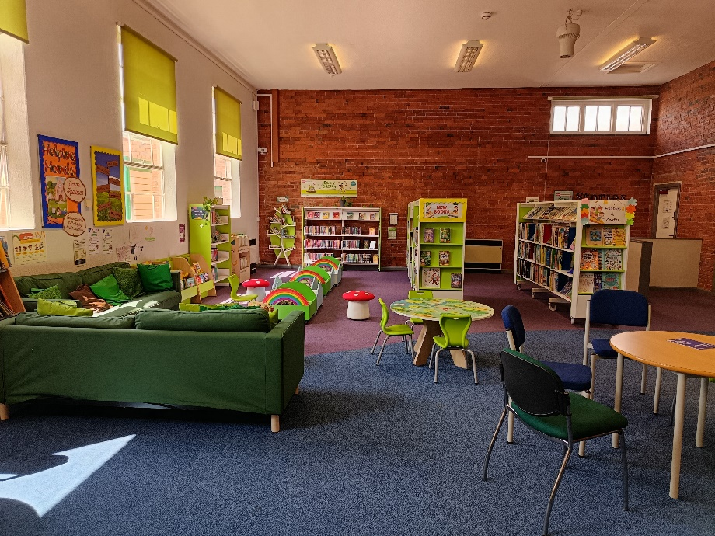
Photo 1 – the children’s area and National Forest-themed furniture

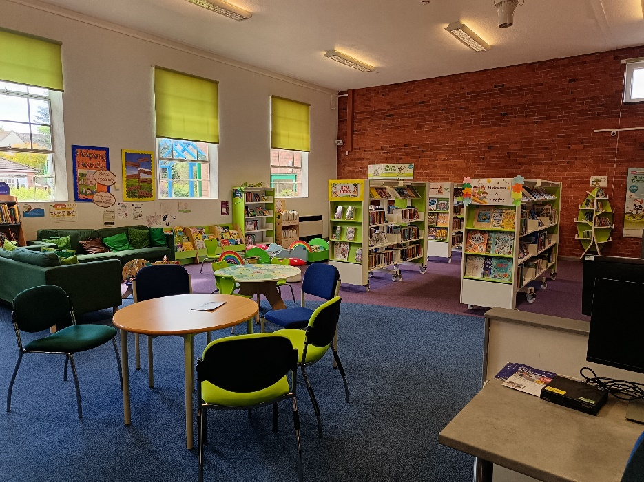
Photo 2 – Children’s area

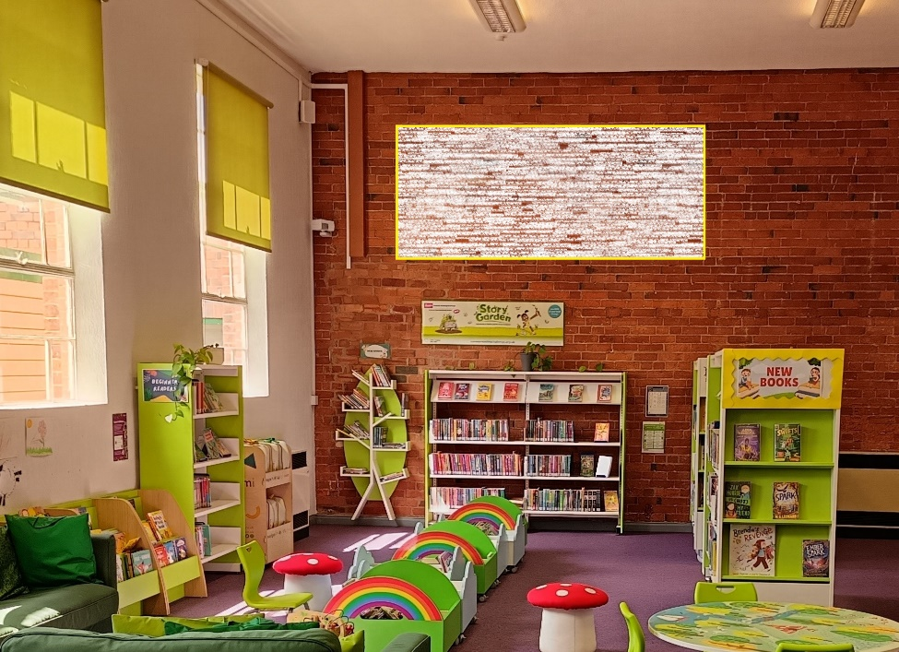
Photo 3 – proposed area for artwork (shaded box on brick wall space)

